Machine Learning (CS365)

Assignment - 1

**U19CS012**

Each student will explore one application in different domain, analyze in it in terms of

* requirements
* levels or hierarchy of data access
* variables or attributes of applications

A.) **Application Domain**:

Online Sales and Inventory Management System (**SIMS**) for a Departmental Store



B.) **Problem Statement**:

To store the Details of the Inventory, Update the Inventory based on the Sale Details, Produce Receipts for sales, and Generate Sales and Inventory Reports Periodically.

To Make an Integrated System that contains

* **User** Component (used by Salespersons / Sales or Inventory Managers)
* **Admin** Component (used by Administrators for performing Admin Level Functions such as adding new items to the inventory, changing the price of an item).

C.) **Analysis**

1.) Design:

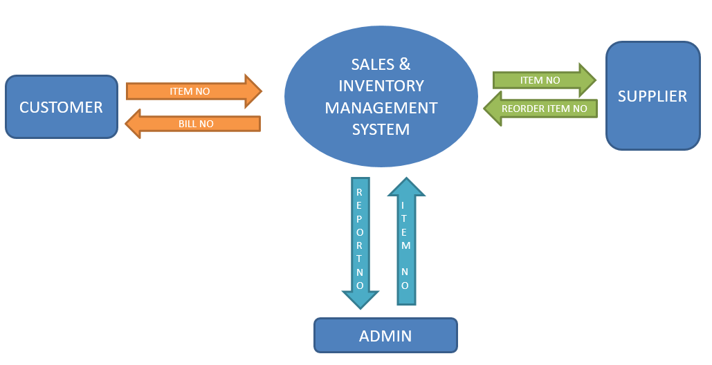

2.) Data Attributes:

* Sales Manager
* Sales Person
* Inventory Manager
* Admin
* Product/Item



3.) Requirements:

**Functional Requirements**

* Log In
* Process sale
  + Allow user to scan items purchase by each customer. The system will display the description of the items and process the total sales and generate receipt for the customers.
* Tracking inventory level
  + Admin able to track the inventory level of each items in line with the sales made.
* Update database
  + Allow admin to update the inventory data in the database that will be used when processing sale.
* Generate report
  + Reports on daily, weekly and monthly sales of the store will be generating so that the owner can view the performance of the business and take appropriate actions

**Non-Functional Requirements**

* Operational Requirements

The system is required to be operated in the computer and able to update database based on point of sale of each customers. Moreover, the system can generate daily, weekly and monthly report on sales performance.

* Performance Requirements

This system should not take more than 5 seconds to load information and it should not delay more than 2 seconds for user respond.

* Security Requirements

Not all staff can access the system apart from the staffs that are responsible in processing customers’ sale at the cashier. The sales information is confidential and only accessible by the admin.

**Sales Person** should be able to:



* Login to the system through the initial screen of the system
* Change the password after logging into the system
* See the **status** of the inventory, i.e., whether a particular item is available or not
* **Search** for a particular item by typing the initial letters (‘app’ for example may bring up the item ‘apple’ in the top) or by category-wise (apple, for example, may be looked up by going through the category ‘fruits’)
* Enter the items purchased by a customer and produce a **bill** for the same (the bill will have a unique sale id, date, time, item/quantity/price details)
* **Cancel** the produced bill, in case of error in entering the details, and produce a new one
* Take back an already sold item that is not satisfactory to the customer (the shop allows that) and produce a receipt for the same
* **Inform** the Inventory manager about the items that are not available, so that they can be stocked
* Inform the sales manager about any **exceptions** (such as an item is being purchased, but it is not available in the system)
* Get help about the system on how to use the different features of the system

**Inventory Manager** should be able to:



* Login to the system/change his password after logging in
* Check the **status** of the inventory
* See the reports from sales people about items that are not available and need to be kept in the inventory
* **Validate the inventory** against the sales done in the previous day (whether the items that are sold and the change in the inventory for the corresponding items match)
* Generate inventory reports of the items category-wise, price-wise.
* Generate inventory-trends (like how is coffee powder stock changing over the month)

**Sales Manager** should be able to:



* **Login** to the system/change his password after logging in.
* Check how many **Bills** have been generated in the day so far
* Check how much **Money** is transacted in the day so far
* Check how many bills have been cancelled so far in the day(due to wrong entry by the sales persons)
* Check how many items have been returned so far in the day
* Check for any exception reports from the sales persons and correct it by contacting the inventory manager
* Generate sales-trend graphs for each of the item (like how is apple selling in the last one month)

**Administrator** should be able to:



* Login to the system and change his password after logging in
* Add new Users to the system
* Add new items/categories to the inventory (‘grape’ may be added to the category ‘fruits’ or a new category such as ‘vegetables’ may be added) change the price of an item

4.) Application End Users

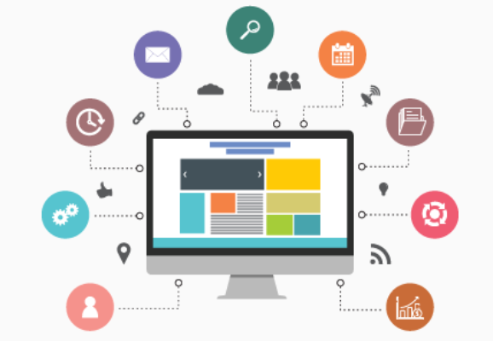

* Sales Manager
* Sales Person
* Inventory Manager
* Admin
* Customer

5.) Functionality [Data Flow Diagram]

{How data exchange required among different entities in the application}

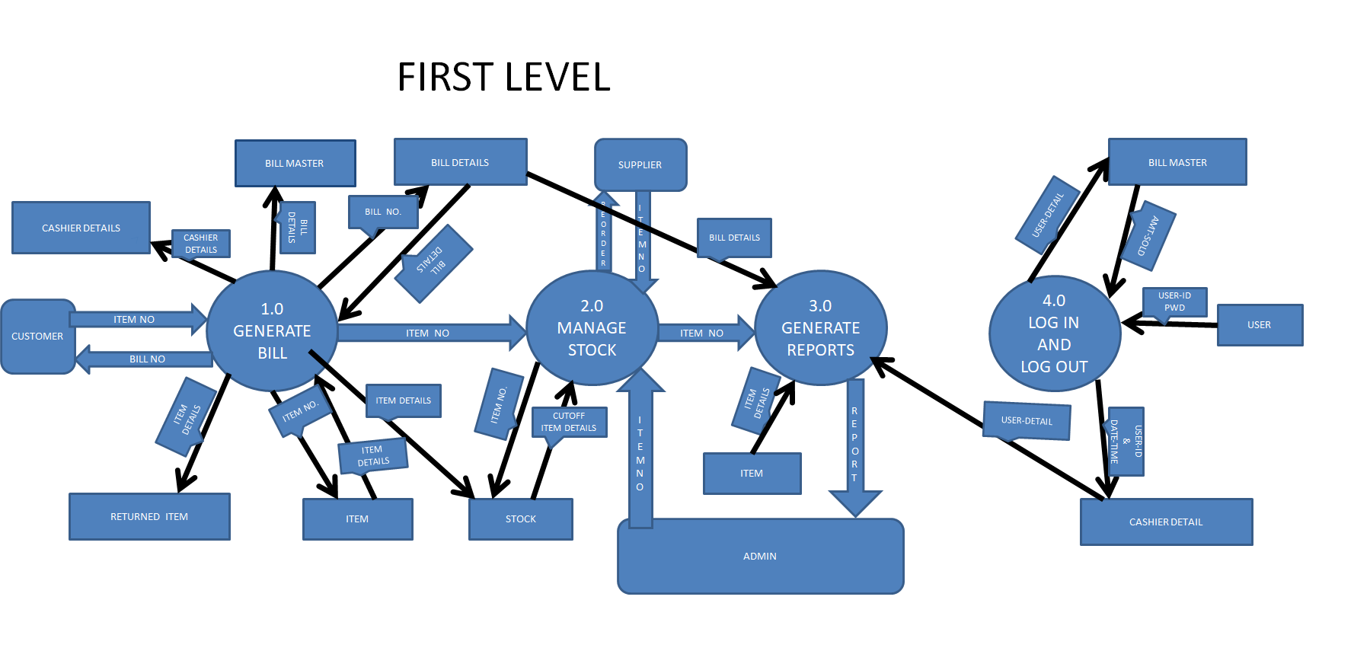

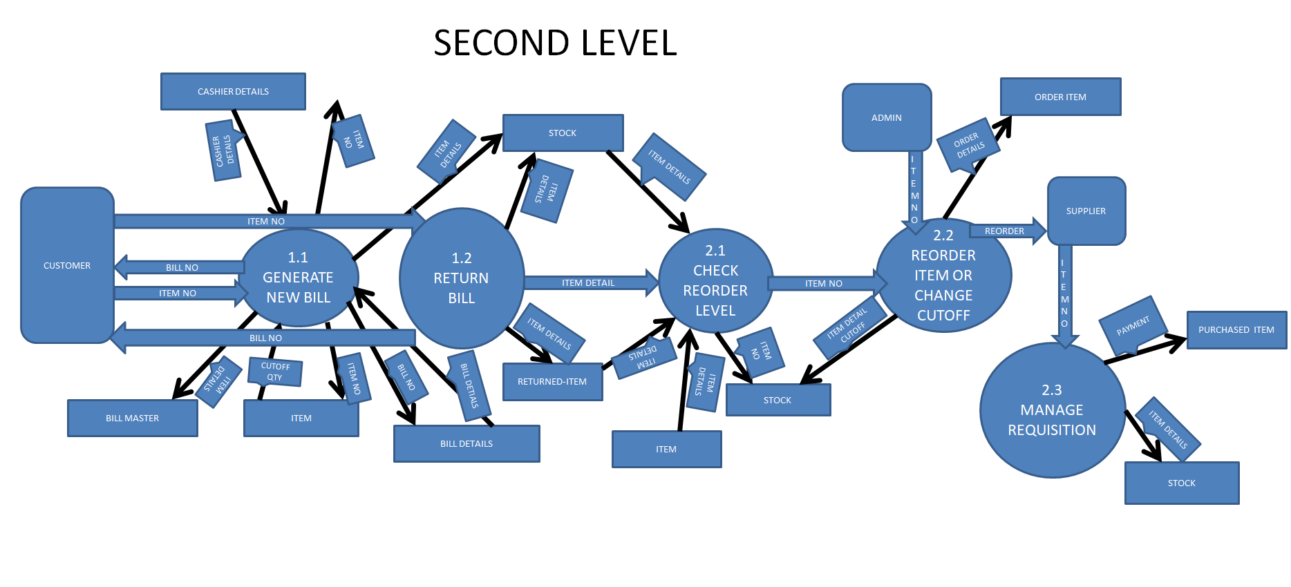

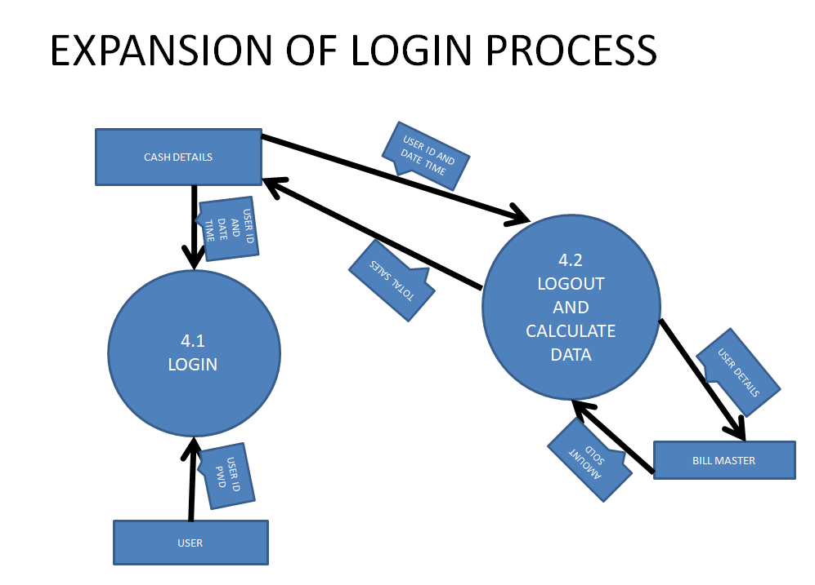

SUBMITTED BY:

**U19CS012**

BHAGYA VINOD RANA